**SQL QUERIES**

KPI’s

* Total Revenue

select sum(price*quantity) As Revenue from details ;



* Net Revenue

select Round(Sum(price*quantity) - Sum(price*quantity*discount/100)+ sum(shipping_cost),2) As Net_Revenue from details;



* Average Order Value

SELECT round(Round(Sum(price*quantity) - Sum(price*quantity*discount/100)+sum(shipping_cost),2)/count(distinct(customer_id)),2) AS AOV from details;



* Total Customers

select count(distinct Customer_Id) as total_customers from details;



* Repeat Customers

select count(*) as repeat_customers from (select count(customer_id) from details

group by customer_id

having count(*)>=2) details;



* Promotion Cost

select round(sum(price*quantity*discount/100),2) as promotion_cost from details;



* Average Delivery Days

Select round((avg),2) from details;



SALES AND REVENUE METRICS

* Monthly Revenue

select month(order_date) as months , monthname(order_date)as name, Round(Sum(price*quantity+shipping_cost) - Sum(price*quantity*discount/100),2) As Net_Revenue from details

group by month(order_date), monthname(order_date)

order by months asc;

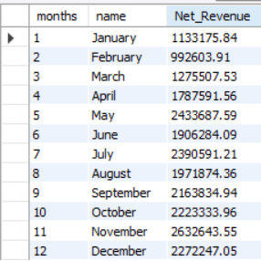

* Weekday VS Weekday Sales

select case when dayofweek(order_date) in (2,3,4,5,6) then "Weekday"

when dayofweek(order_date) in (1,7) then "Weekend"

else "unknown"

end as `Week(day/end)`,

Round(Sum(price*quantity) - Sum(price*quantity*discount/100)+ sum(shipping_cost),2) As Net_Revenue

from details

group by `Week(day/end)`;

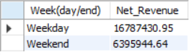

PRODUCT-CATEGORY BASED METRICS

* Product-category

select product_category, count(quantity) quantity , Round(Sum(price*quantity) - Sum(price*quantity*discount/100)+ sum(shipping_cost),2) As Net_Revenue from details

group by product_category

order by NET_REVENUE asc;

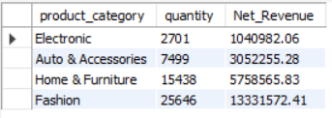

* Top selling products

select product,count(quantity) quantity , Round(Sum(price*quantity) - Sum(price*quantity*discount/100)+ sum(shipping_cost),2) As Net_Revenue from details

group by product

order by net_revenue desc;

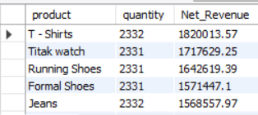

* Least selling products

select product, count(quantity) quantity,Round(Sum(price*quantity) - Sum(price*quantity*discount/100)+ sum(shipping_cost),2) As Net_Revenue from details

group by product

order by sales asc;

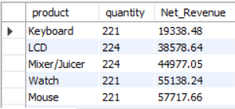

CUSTOMER METRICS

* Repeat customers

select count(*) as repeat_customers

from (select count(customer_id) from details

group by customer_id

having count(*)>=2) details;



* Gender

select gender, Round(Sum(price*quantity+shipping_cost) - Sum(price*quantity*discount/100),2) as net_revenue from details

group by gender;

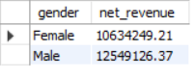

* Customer Login Type

select customer_login_type , Round(Sum(price*quantity+shipping_cost) - Sum(price*quantity*discount/100),2) as net_revenue from details

group by customer_login_type;

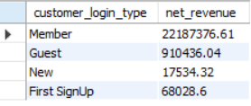

* Time Segment

select case when hour(order_time) between 5 and 11 then "Morning (5AM-11AM)"

when hour(order_time) between 5 and 11 then "Morning (5AM-11AM)"

when hour(order_time) between 12 and 4 then "Afternoon (12PM-4PM)"

when hour(order_time) between 5 and 8 then "EVENING (5PM-8PM)"

ELSE "NIGHT (9PM-4AM)" END AS Time_Segment, count(customer_id) customers FROM details

GROUP BY Time_Segment;

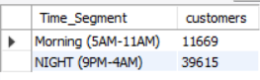

OPERATIONAL (LOGISTICS) METRICS

* Delay deliveries

select count(*) as delay from details

where aging >(select avg(aging) from details);



* Within time deliveries

select count(*) as within_time from details

where aging <= (select avg(aging) from details);



* Min VS Max shipping cost

select min(shipping_cost) as min_shop_cost, max(shipping_cost) max_ship_cost from details;



* Order Priority

select order_priority, Round(Sum(price*quantity) - Sum(price*quantity*discount/100)+ sum(shipping_cost),2) As Net_Revenue from details

group by order_priority

order by net_revenue desc;

